Primary Standards
# Source: AI Source: Provided by: [Data Path: Persons Table -> ID Column: 1, Name_En Column: Motasem Essam] -> From: [ChatGPT] on [7/17/2026]
Primary Standards are the highest-accuracy measurement standards maintained within a country, national metrology institute, or accredited laboratory. They directly realize a measurement unit from its official definition or from internationally accepted physical constants and serve as the reference for calibrating all lower-level standards.
Primary standards are traceable to international standards (SI) and provide the highest level of measurement accuracy available within a national measurement system.

Definition
# Source: AI Source: Provided by: [Data Path: Persons Table -> ID Column: 1, Name_En Column: Motasem Essam] -> From: [ChatGPT] on [7/17/2026]
A Primary Standard is a measurement standard that has the highest metrological quality within a country or organization and is used as the reference for assigning values to secondary standards.
A primary standard realizes a measurement unit directly from its definition without requiring calibration from another standard of the same quantity.

Purpose
# Source: AI Source: Provided by: [Data Path: Persons Table -> ID Column: 1, Name_En Column: Motasem Essam] -> From: [ChatGPT] on [7/17/2026]
Primary standards are used to:
- Realize measurement units.
- Maintain national measurement accuracy.
- Calibrate secondary standards.
- Support scientific research.
- Establish measurement traceability.
- Ensure consistency across laboratories.
- Support industry and commerce.

Characteristics
# Source: AI Source: Provided by: [Data Path: Persons Table -> ID Column: 1, Name_En Column: Motasem Essam] -> From: [ChatGPT] on [7/17/2026]
Primary standards are:
- Extremely accurate.
- Highly stable.
- Traceable to the International System of Units (SI).
- Carefully maintained.
- Used only for high-level calibration.
- Subject to rigorous verification and documentation.

Position in the Measurement Hierarchy
# Source: AI Source: Provided by: [Data Path: Persons Table -> ID Column: 1, Name_En Column: Motasem Essam] -> From: [ChatGPT] on [7/17/2026]
Primary standards occupy the second-highest level in the measurement hierarchy.
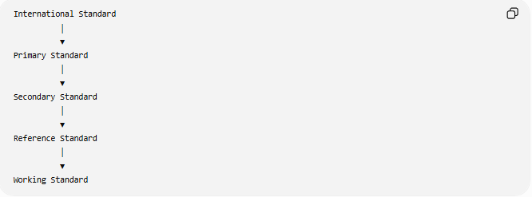
International Standard
│
▼
Primary Standard
│
▼
Secondary Standard
│
▼
Reference Standard
│
▼
Working Standard

Who Maintains Primary Standards?
# Source: AI Source: Provided by: [Data Path: Persons Table -> ID Column: 1, Name_En Column: Motasem Essam] -> From: [ChatGPT] on [7/17/2026]
Primary standards are maintained by National Metrology Institutes (NMIs).
Examples include:

Country | National Metrology Institute
United States | National Institute of Standards and Technology (NIST)
United Kingdom | National Physical Laboratory (NPL)
Germany | Physikalisch-Technische Bundesanstalt (PTB)
France | Laboratoire National de Métrologie et d'Essais (LNE)
Japan | National Metrology Institute of Japan (NMIJ)
These institutes ensure that their primary standards remain traceable to internationally accepted definitions.

Functions of Primary Standards
# Source: AI Source: Provided by: [Data Path: Persons Table -> ID Column: 1, Name_En Column: Motasem Essam] -> From: [ChatGPT] on [7/17/2026]
Primary standards are used to:
- Realize SI units.
- Calibrate secondary standards.
- Verify national measurement accuracy.
- Participate in international comparisons.
- Support calibration laboratories.
- Provide measurement traceability.

Examples of Primary Standards
# Source: AI Source: Provided by: [Data Path: Persons Table -> ID Column: 1, Name_En Column: Motasem Essam] -> From: [ChatGPT] on [7/17/2026]
Length
A national realization of the meter using laser interferometry based on the SI definition.

Time
A national cesium atomic clock realizing the SI second.

Mass
A national realization of the kilogram based on the Planck constant.

Electric Voltage
A Josephson Voltage Standard, which realizes the volt using the Josephson effect.

Electrical Resistance
A Quantum Hall Resistance Standard, which realizes the ohm using the quantum Hall effect.

Temperature
Fixed-point cells and precision thermometry that realize the kelvin according to the International Temperature Scale.

Traceability
# Source: AI Source: Provided by: [Data Path: Persons Table -> ID Column: 1, Name_En Column: Motasem Essam] -> From: [ChatGPT] on [7/17/2026]
Primary standards are directly traceable to international definitions.
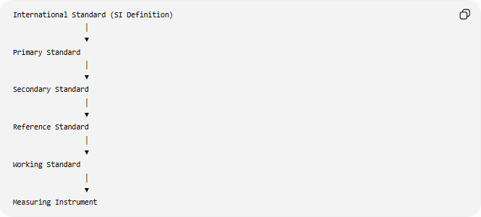
International Standard (SI Definition)
│
▼
Primary Standard
│
▼
Secondary Standard
│
▼
Reference Standard
│
▼
Working Standard
│
▼
Measuring Instrument

Advantages
# Source: AI Source: Provided by: [Data Path: Persons Table -> ID Column: 1, Name_En Column: Motasem Essam] -> From: [ChatGPT] on [7/17/2026]
Primary standards:
- Provide the highest national measurement accuracy.
- Ensure long-term stability.
- Support calibration traceability.
- Improve scientific reliability.
- Enable international measurement consistency.
- Support industrial quality assurance.

Applications
# Source: AI Source: Provided by: [Data Path: Persons Table -> ID Column: 1, Name_En Column: Motasem Essam] -> From: [ChatGPT] on [7/17/2026]
Primary standards are essential in:
- National metrology institutes.
- Scientific research.
- Calibration laboratories.
- Aerospace.
- Electronics.

Medicine.
- Manufacturing.
- Telecommunications.
- Defense.
- International trade.

Everyday Importance
# Source: AI Source: Provided by: [Data Path: Persons Table -> ID Column: 1, Name_En Column: Motasem Essam] -> From: [ChatGPT] on [7/17/2026]
Although the public rarely interacts directly with primary standards, they help ensure:
- Accurate grocery scales.
- Reliable fuel pumps.
- Correct medical equipment.
- Precision manufacturing.
- Fair commercial transactions.
- Accurate GPS timing.
- Consistent electricity measurements.

Common Mistakes
# Source: AI Source: Provided by: [Data Path: Persons Table -> ID Column: 1, Name_En Column: Motasem Essam] -> From: [ChatGPT] on [7/17/2026]
- Confusing primary standards with international standards.
- Assuming primary standards are used for routine measurements.
- Believing every laboratory owns a primary standard.
- Confusing primary standards with working standards.

Key Points
# Source: AI Source: Provided by: [Data Path: Persons Table -> ID Column: 1, Name_En Column: Motasem Essam] -> From: [ChatGPT] on [7/17/2026]
- Primary standards are the highest measurement standards maintained nationally.
- They are directly traceable to the SI.
- They are used to calibrate secondary standards.
- They provide the highest measurement accuracy available within a country.
- They are maintained by national metrology institutes.

Primary Standards vs. International Standards
# Source: AI Source: Provided by: [Data Path: Persons Table -> ID Column: 1, Name_En Column: Motasem Essam] -> From: [ChatGPT] on [7/17/2026]
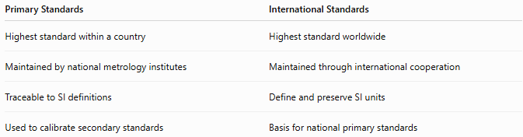
Primary Standards | International Standards
Highest standard within a country | Highest standard worldwide
Maintained by national metrology institutes | Maintained through international cooperation
Traceable to SI definitions | Define and preserve SI units
Used to calibrate secondary standards | Basis for national primary standards

Primary Standards vs. Secondary Standards
# Source: AI Source: Provided by: [Data Path: Persons Table -> ID Column: 1, Name_En Column: Motasem Essam] -> From: [ChatGPT] on [7/17/2026]
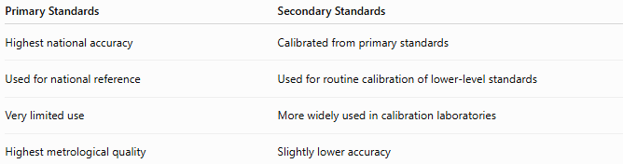
Primary Standards | Secondary Standards
Highest national accuracy | Calibrated from primary standards
Used for national reference | Used for routine calibration of lower-level standards
Very limited use | More widely used in calibration laboratories
Highest metrological quality | Slightly lower accuracy

Primary Standards vs. Working Standards
# Source: AI Source: Provided by: [Data Path: Persons Table -> ID Column: 1, Name_En Column: Motasem Essam] -> From: [ChatGPT] on [7/17/2026]
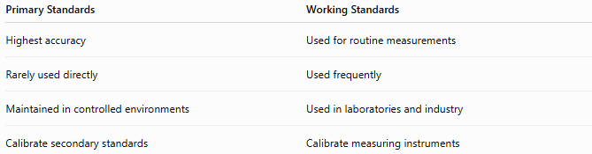
Primary Standards | Working Standards
Highest accuracy | Used for routine measurements
Rarely used directly | Used frequently
Maintained in controlled environments | Used in laboratories and industry
Calibrate secondary standards | Calibrate measuring instruments

Conclusion
# Source: AI Source: Provided by: [Data Path: Persons Table -> ID Column: 1, Name_En Column: Motasem Essam] -> From: [ChatGPT] on [7/17/2026]
Primary Standards are the highest-accuracy measurement standards maintained within a country or organization. They realize measurement units directly from internationally accepted definitions and provide the national reference for all lower-level standards. Maintained by National Metrology Institutes (NMIs), primary standards ensure measurement traceability, accuracy, and consistency across science, engineering, manufacturing, healthcare, and commerce. They form the critical link between international standards and the practical measurements used throughout society.

